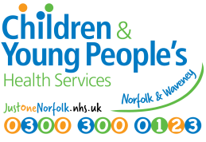
p1 of 11

Parental consent MUST be obtained prior to the referral being made.
CHILDREN’S SPEECH & LANGUAGE THERAPY (SaLT) REFERRAL
(Referral will be declined or delayed if information is missing)
PLEASE COMPLETE FULLY IN BLACK INK.

Child’s name: | D.o.b.: | NHS no:
Address: |  | Gender:
Parent/Carer 1: | Phone: | Email:
Address if different:

Parent/Carer 2: | Phone: | Email:
Address if different:

Others with Parental Responsibility: | Phone: | Email:
Address if different:

GP: GP surgery:

School/Nursery/Preschool:

Referrer Information and Parent/Carer Consent
(Referral will not be accepted without a signature from parent/carer)
Parental Consent for SLT referral: Yes ☐ (see below if face-to-face consent not gained)

Signature of parent/carer: ……………………………………………

Name of parent/carer: ……………………….………………………..

I confirm that I have Parental Responsibility for ……..................................... Yes ☐
Date: .....................

Cambridgeshire Community Services (CCS) NHS Trust would like to send text (SMS) messages for appointment reminders and general information.
I agree to receive text (SMS) messages: Yes ☐ No ☐

We may offer appointments using video calling; for this we need your current email address.
I agree to having video call appointments if appropriate: Yes ☐ No ☐

We often send letters or reports by email instead of by post. Any such correspondence is always sent via encrypted email; in order to receive such emails you would need to respond to an initial request to set up a username and password by Egress Software. Once any information has left our NHS email accounts, the security of that information would be your responsibility. It would also be your responsibility to update any change of email address. Once any information has left our secure NHS email accounts, the security of the information is your responsibility.

I agree to receive encrypted emails which could include personal information: Yes ☐ No ☐
Child’s name: | D.o.b.: | NHS no: p2 of 11
Sharing information:
Are you happy for us to share your child’s record with other health services who are involved with your child’s care? Yes ☐ No ☐
Are you happy for us to have access to the records held by other health services involved in your child’s care? Yes ☐ No ☐
If we need to talk to other professionals involved with your child, e.g. Paediatrician, Portage worker or school staff etc, are you happy for us to share information with them? Yes ☐ No ☐

Referrer information: (please complete the following three lines if parental signature not gained)
I confirm I gained the consent(s) as above: Yes ☐
Date consent(s) gained: ……………………………..

Name of parent/carer giving consent(s): ……………………………………………………………………..

I confirm that the person giving consent has Parental Responsibility: Yes ☐

Name of person making referral: Signature:

Job title/designation: Telephone number:

Email address:

Reason for Referral - please outline the difficulties observed below:
Area of difficulty (relative to overall ability) | Area of concern?  Yes/No | Comments/observations (please provide as much information as possible)
Attention & listening
Verbal comprehension (understanding of language)

Expressive language (spoken language)
Speech Sounds |  | Please only complete speech sound screen for a verbal child where there are concerns around speech. (See p6 for instructions)
Play & interaction
Social communication (i.e. use of language for a range of purposes e.g. asking questions, making jokes and use of non-verbal communication e.g. eye contact, facial expressions)
Child’s name: | D.o.b.: | NHS no: p3 of 11
Fluency (e.g. stammer)
(If fluency is the ONLY referral reason, evidence of a plan do review cycle is not required.)

Please include information around how long the stammer has been present for, if there is a family history and try and describe the stammer (e.g. sound repetitions, word repetitions, blocking,
facial grimaces etc)
Voice NB: We can only accept referrals for voice difficulties once ENT have assessed vocal cord function; our service can only give one-off advice for voice difficulties. Evidence of plan do review is not required for voice issues.
Other
Evidence of a plan, do, review cycle from a setting is required if the child attends an educational setting
e.g. school or preschool/nursery) A formal screen AND RESCREEN should be included with outcomes/progress following setting-based input recommended from the screen – REFERRALS WILL BE REJECTED IF THIS IS NOT PRESENT. (Children with recognised complex needs may not require this evidence.) Please see our website for accepted screens and interventions.

What screens have been carried out with the child? Please also attach/enclose screening assessment with this referral)

What intervention has been carried out with the child? (Please also attach/enclose evidence of intervention with this referral form). Intervention can be 1:1 or small group work.
Please add comments about other aspects of the child’s development: e.g. child’s general level of ability, coordination, reading and writing skills etc. (include information about areas of strength as well as difficulty):

Child’s name: | D.o.b.: |  | NHS no: p4 of 11
What is the desired outcome of this referral to the Speech & Language Therapy team?
If targets and/or strategies are recommended by the Speech & Language Therapist, who will be able to carry these out or support their implementation?
Safeguarding issues
Any Child Protection Issues?  Y N |  | Is this child known to Social Services?  Y N |  | Is this child a Child in Need?  Y N
Is this child subject to a Child Protection Plan?  Y N |  | Is this child a Looked After Child?  Y N |  | Has there been a Family Support Plan?  Y N
If yes to any of the above, please add the following information, as appropriate:
Social worker:

Name of family support worker: Name(s) of foster carer(s):

Does the child have any vision or hearing difficulties?

Date of last hearing test:
Are there any relevant diagnoses or medical problems?

Child’s name: | D.o.b.: | NHS no: p5 of 11
Names of other key professionals involved: (E.g. Paediatrician, Portage Worker, Educational Psychologist)
Please attach any relevant reports.
Any other concerns:

Does the child have an Education and Health Care Plan (EHCP?)
Has the Child previously been referred to Speech & Language Therapy?
Details:

If the child has had previous targets set by a Speech and Language Therapist, please outline the progress that they have made with these:

Target: |  |  | Progress made/other comments:

Child’s name: |  | D.o.b.: | NHS no: p6 of 11
Note: Home visits are often made by a lone worker.
Are there any issues / concerns about lone workers and this family? Yes No
Details:
Language(s) spoken at home:

By child:

By other family members:
Are the concerns noted in all languages spoken? Yes No

Is an interpreter needed for parent/carer? Yes No
We are required by the Government to monitor that all health services are equally accessible to all groups within the community. Please indicate which of the following best describes your child’s ethnic origin:
White | British |  |  |  | Black or Black British | Caribbean
 | Irish |  |  |  |  | African
 | Any other white background |  |  |  |  | Any other Black background
Mixed | White & Black Caribbean |  |  |  | Other ethnic | Chinese
 | White & Black African |  |  |  |  | Any other ethnic category
 | White & Asian |  |  |  | I prefer not to say what ethnic origin is
 | Any other mixed background |  |  |  | Child’s religion: ………………………………………….  (please leave blank if you prefer not to say)
Asian & British Asian | Indian
 | Pakistani
 | Bangladeshi
 | Any other Asian background
Notes to referrer
Please post referral to:

Norfolk and Waveney Children and Young People's Health Services
Children's Speech & Language Therapy,
Unit 3, Cringleford Business Centre
Intwood Road
Norwich, Norfolk
NR4 6AU

Or email the referral to: ccs.nandw-salt-jon@nhs.net

Please attach any recent and relevant reports, and the speech sound screen if appropriate.

Documents to attach to referral (if appropriate):

Educational Psychologist report:
Report from Advisory/Specialist teacher:
Report from Community Paediatrician:
ECCH SaLT speech sound screen:
Other speech/language screening tool e.g. SpeechLink, Wellcomm (please specify):
Other report/document (please specify):

p7 of 11

p8 of 11

Speech Sound Screen

Please complete if referring a child with speech sound difficulties

- Ask the child to name the pictures one by one. Make sure you listen really carefully and write down the word exactly as the child says it.
- If the child is unable to name the picture then say the word for them and ask them to repeat it but make a note that it was repeated.
For example
Target Word | Child's production of the word
 | Date: | Date: | Date:
mouse | mou
spider | biyer

Recommendations
If the child isn’t saying the sounds expected for their age (see Appendix 1) and this is the main area of speech and language difficulty :

- Follow the advice handout ‘Supporting Children with Unclear Speech’ AND

- If the child is older than 3 years carry out a phonological awareness programme for a minimum of 8 weeks at least three times a week (preferably in a group)

- Record your intervention using the record sheet attached.

- Repeat the phonological screen using the same record sheet to measure progress.

- NB If the child is older than 3 and uses less than 6 different consonant sounds and is very difficult to understand then please refer to SLT immediately with copy of speech sound screen (but still carry out phonological awareness activities).

If the child :
- has made minimal progress (following the above intervention) OR

- has made some progress but still shows many errors AND/ OR

- is very difficult to understand

Then make a referral to SLT

p9 of 11

Speech Sound Screen Record Sheet
Child’s Name : Date of Birth:
Target Word | Child’s Production of the Word
 | (Before intervention)  Date: | (After a minimum of 8 weeks intervention)  Date:
mouse
pig
two
door
car
fish
sun
sheep
chair
leaf
driving
jelly
witch
black
flower
cloud
green
tree
spider
sky
butterfly
helicopter

p10 of 11
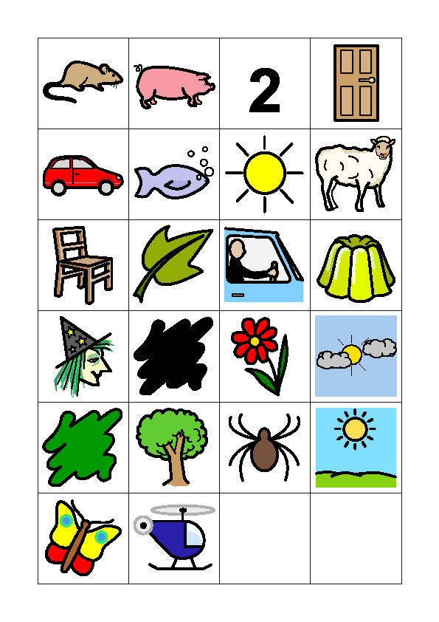

p11 of 11

Speech and Language Therapy Appendix 1

Speech Sound Development

Approximate Age of acquisition | Sounds
3 years | p, b, t, d, m, n, f, s, z, h, w, y
3-4 years | k, g, ng
4-5 years | l, r, ch and j  l, w, r and s consonant blends e.g floor, train, spider, twelve, nest, qu(kw)een
6-7 years | r, th

Speech sound processes

Children go through a pattern of simplifying sounds when developing their speech. These simplifications are called ‘phonological processes’ and are part of normal development.
See below for the most frequent phonological processes :

Phonological process | Example | Approximate age the process should disappear
Final consonant deletion | The final consonant is  omitted. e.g. bus -bu, sock -so | 3 years
Fronting | Sounds made at the back of the mouth are replaced with sounds made at the front. e.g. car-tar, girl-  dirl. | 3 -4 years
Stopping | Long sounds are replaced by short sounds e.g. sun- dun, fire-pire , shop-top | 3 – 4 years
Weak syllable deletion | The weak syllable is omitted. e.g. nana for banana, puter for  computer | 4 -5 years
Cluster reduction | Words with two or more consonants together are simplified to one consonant. e.g. flower- fower, crab- cab, spoon poon, star-tar | 4- 5 years
Gliding | l and r sounds are replaced by w and y sounds. e.g. rabbit-  wabbit, like-wike | 5-6 years

