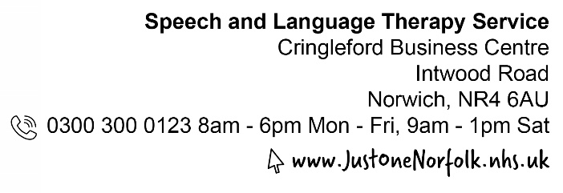

Checklist for a communication friendly environment

The environment is important for supporting communication as well as learning, social and emotional development. A communication friendly environment provides opportunities for everyone to talk, listen, understand and take part. A communication friendly environment benefits all children, not just those with Speech, Language and Communication Needs (SLCN).
You can use this checklist to see how communication friendly your setting already is and identify areas to develop.
Class/room name:
Date:
Completed by:
Checklist summary:
What’s working well:

Areas to develop:

Date to review checklist:

There are some simple things you can do to make your environment more communication friendly. Below you can find some suggestions of things to consider.

- The communication environment:
Noise and Distraction levels:
- Background noise is manged appropriately to minimise distraction and kept to a minimum where possible (e.g., windows closed where appropriate).
- Adults ensure they are not carrying out jobs in view or in ear shot during group times.
- The is an area which is visually calm and clutter free.
- Adults are aware of noise levels in the room – There are quieter and noisier zones.

Space, light and layout:
- There are quiet areas available in the setting where children can retreat to have ‘down time’ or engage in smaller group activities. These areas are less visually distracting.
- There is a specific area to access and share books.
- There are clearly defined spaces for learning - both indoors and outdoors (if appropriate for age group).
- There are areas where natural light is maximised, windows are not restricted by paintings/displays or blinds.
- There are a range of different lit areas which are appropriate for those with sensitivities.
- The furniture is arranged to promote eye contact and face to face communication.
- Resources are easily accessible and organised clearly (e.g., in clear boxes or neutral baskets).
- Displays are not excessive; the use of colour is not overpowering.
- The setting is calm, organised and clutter free.

Resources:
- Visual timetables use pictures that are appropriate for the children. They are used consistently throughout the day.
- Objects, pictures and symbols are used to teach vocabulary, explore stories and make activities interactive.
- Photographs or symbols are used to support routine (e.g. washing hands, getting ready for outdoor play).
- Resources are clearly labelled (e.g. with words, pictures, or symbols as appropriate).
- There are a range of resources developmentally appropriate for the stage of the pupils and linked to their interest.
- There is a book area in each classroom which is developmentally appropriate for the stage of the pupils and includes non-fiction.

- Interactions and Total Communication
Adults support positive interactions by:
- Getting down to the child’s level when interacting with them.
- Modelling language related to the child’s focus of attention.
- Supporting verbal language with sign supported langauge such as Signalong
- Pausing to allow children time to process and respond.
- Accepting every form of communication
- Commenting on what is happening or what children are doing.
- Giving choices (e.g. “Would you like to read a story or play in the home corner?”).
- Using non-verbal visual communication to support what they say (e.g. gesture, pointing).
- Adults provide opportunities for communication for each individual child.
- Gaining a child’s attention before speaking to them (e.g. by calling their name).

Using visual support:
- Visual timetables use pictures that are appropriate for the children and are at an accessible height. They are used consistently throughout the day.
- Objects, pictures and symbols are used to teach vocabulary, explore stories and make activities interactive.
- Photographs or symbols are used to support routine (e.g. washing hands, getting ready for outdoor play).
- Resources are clearly labelled (e.g. with words, pictures, or symbols as appropriate).

