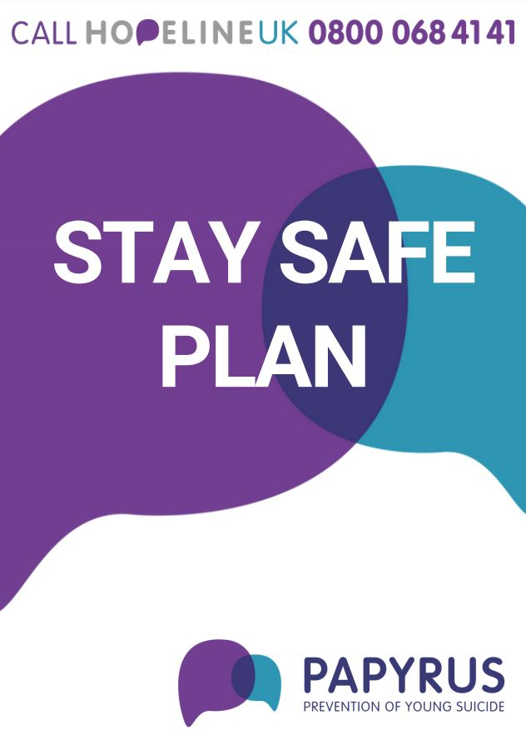

Type here…

**What makes me feel bad? What does this feel like?**

HINT: Has something happened to make you feel this way? What do you currently feel?

**How can I keep myself safe right now?**

HINT: Do you speak to someone for some help? Are there things around you that makes you feel unsafe? Can being somewhere else make you feel safer?

Type here…

What helps me to feel good?

Type here…

**If I need help, who can I ring?**

HINT: Can you ring an adult, a friend or helpline?

**What do I love right now and what are my hopes for the future?**

HINT: Who is important to you in your life? Who do you look up to? What would you like to achieve?

* HOPELINEUK 0800 068 4141
* ChildLine 0800 11 11

Type here…

Type here…

**If I can’t stay safe, who will**

**I tell?**

HINT: Who do you trust? Who is suitable to help you?

**What helps me to feel good?**

HINT: What activity do you like to do? What is your favourite food? Who or what makes you laugh